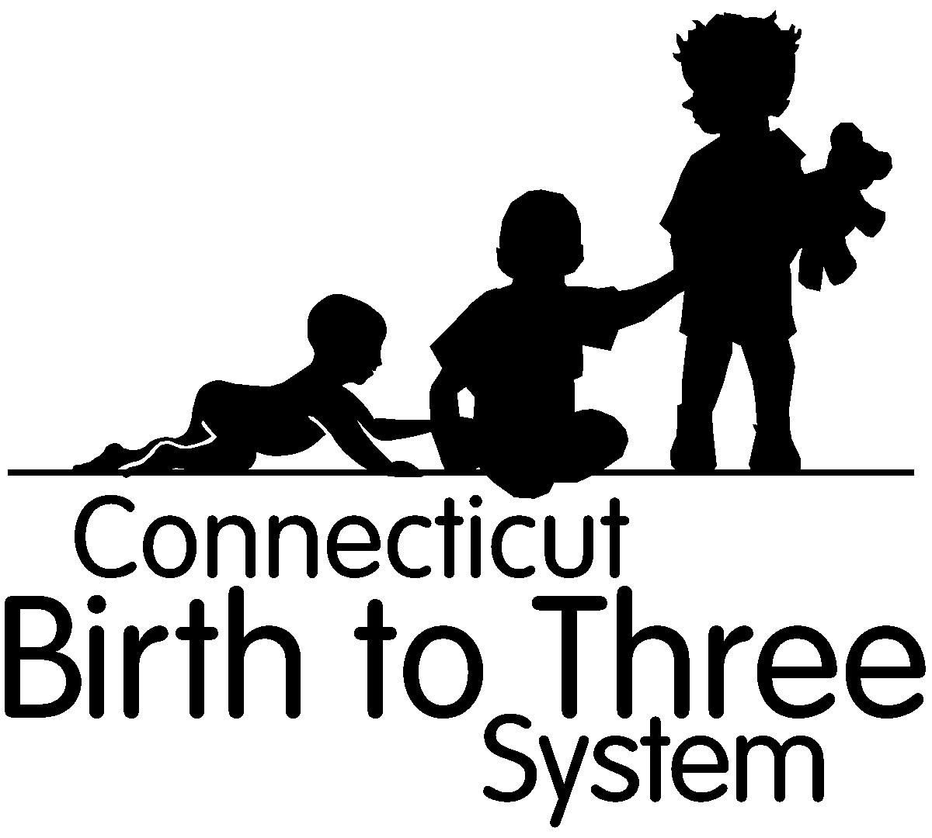 Autism Spectrum Disorder Checklist
(DSM-5 Diagnostic Criteria)
Child:  DOB  B23# | Evaluator:  Program:
Please indicate in the space next to each criterion how the diagnostician knows that the child meets the criteria (for example, an ADOS 2 or other instrument, or observation).
- Persistent deficits in social communication and social interaction across multiple contexts, as manifested by all the following, currently or by history:
Criterion | Please indicate how documented in this column:
- Deficits in social-emotional reciprocity
- Deficits in nonverbal communicative behaviors used for social interactions
- Deficits in developing, maintaining, and understanding relationships.
- Restricted, repetitive patterns of behavior, interests, or activities, as manifested by at least two of the following, currently or by history:
- Stereotyped or repetitive motor movements, use of objects or speech
- Insistence on sameness, inflexible adherence to routines or ritualized patterns of verbal or nonverbal behavior
- Highly restricted, fixated interests that are abnormal in intensity or focus
- Hyper- or hyporeactivity to sensory input or unusual interest in sensory aspects of the environment
Specifiers:
- With or without accompanying intellectual impairment
- With or without accompanying language impairment
- Known etiological factor (s) present (for example medical condition, genetic syndrome, environmental factor):

- Associated with another neurodevelopmental, mental, or behavioral disorder
- Severity (Please circle appropriate level):
Level 1: Requiring support:
Level 2: Requiring substantial support:
Level 3: Requiring very substantial support:
Person completing form (print and sign) credentials/date

CT Birth to Three Form:3-20 (5/1/2015)

