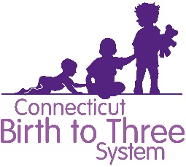
Compliance Conversation: Overview
The last Friday of the month from 12-1.

Audience: Anyone who wants to join us
Purpose: Increase compliance and better support families
Format: A procedure that was determined by the group from the previous month is selected and discussed.
1st -20 min. Review & highlight sticking points
2nd -40 min. Open for questions

Creating a safe space “rules of the group”
- Everyone is welcome to have a say.
- We always treat each other with respect.
- We work towards the positive.
- We aim to share, support, learn and build each other up.
- We are honest and we have fun.
- There is no recording of the meeting by facilitator or attendee.
- There are no notes taken to be shared with members.
- If program specific follow up is needed, it will be done so as a learning opportunity unless it rises to the level of significant non-compliance which will than result in formal monitoring.
  - An example of significant non-compliance is a program that shares that they never send out prior written notification for an IFSP review.

Meeting Talking Points
- What is governing this
- What is the intent
- What is reasonable
- Look at the language (must, could, should…)
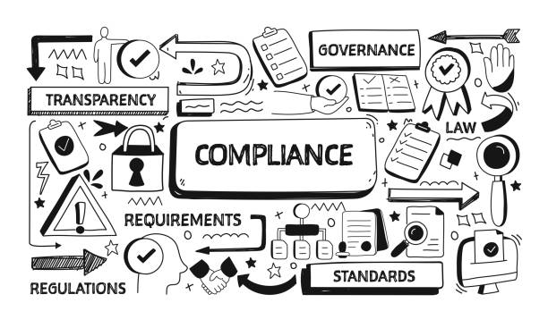

1https://www.gettyimages.com/detail/illustration/compliance-related-doodle-illustration-royalty-free-illustration/1339991463

