Example of the 2 certificates required in the Service Coordination Perquisite “class” assignments. Please ensure that each certificate is upload to the corresponding assignment title.
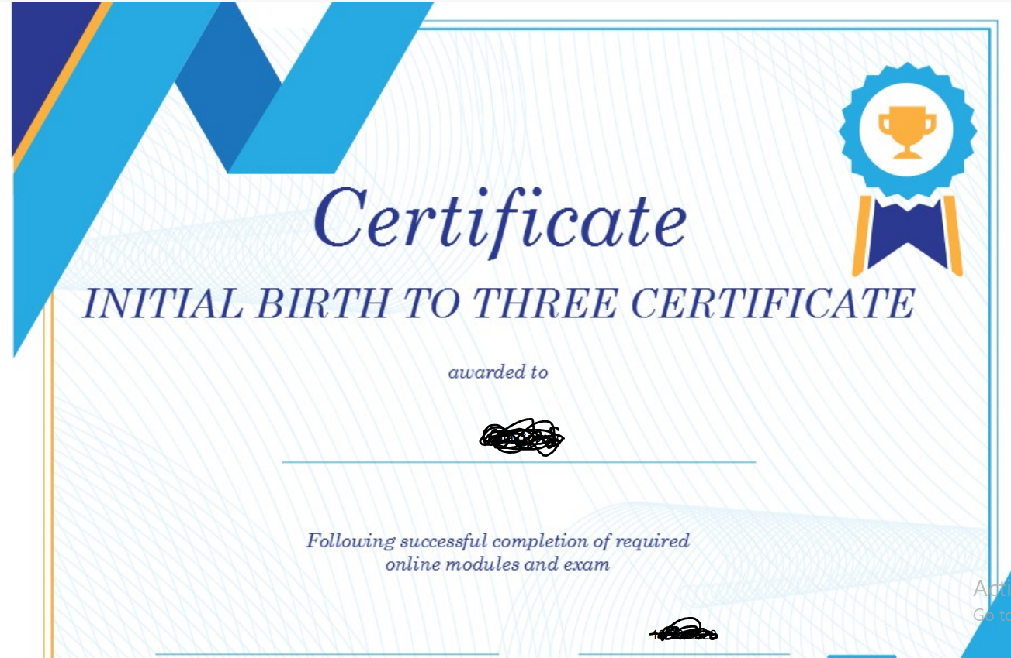
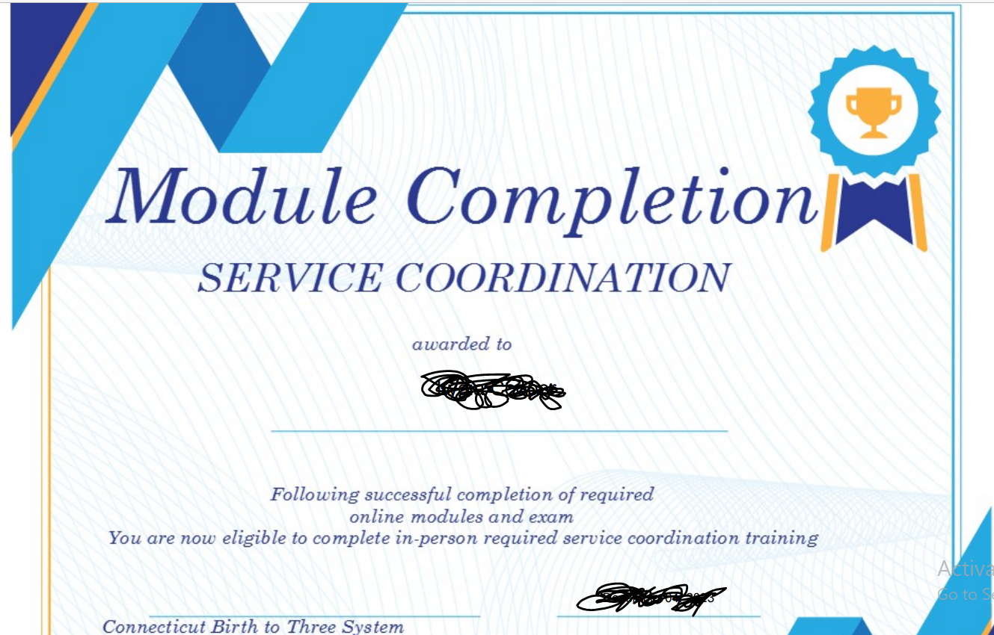

Example of student view with all 3 prerequisites submitted and accepted
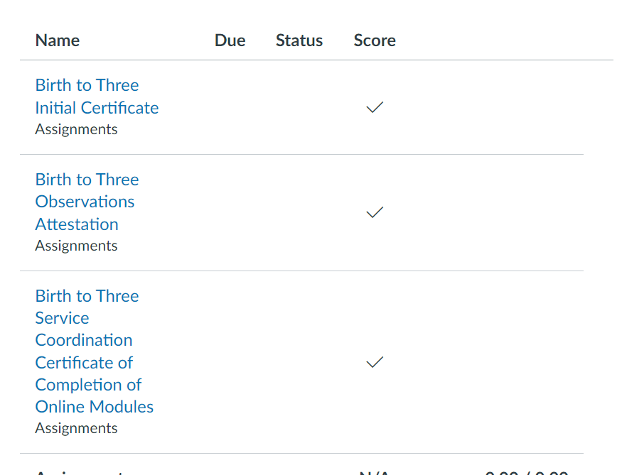

Example of incomplete and incorrect submission with comments (one assignment uploaded correctly and accepted, one assignment uploaded incorrectly that requires moving to correct assignment (has not been moved at this time) and one missing assignment that is completely missing
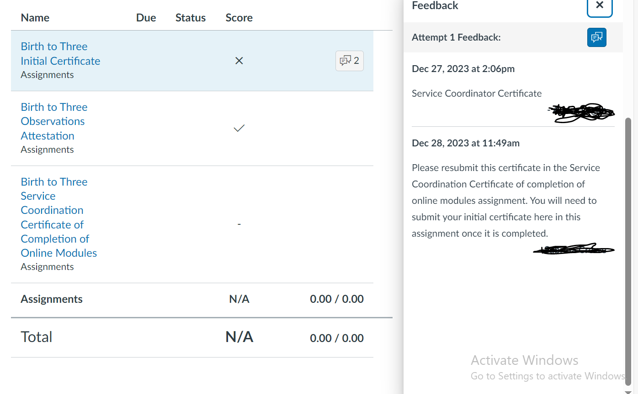

Example of registered staff member with no submissions uploaded
