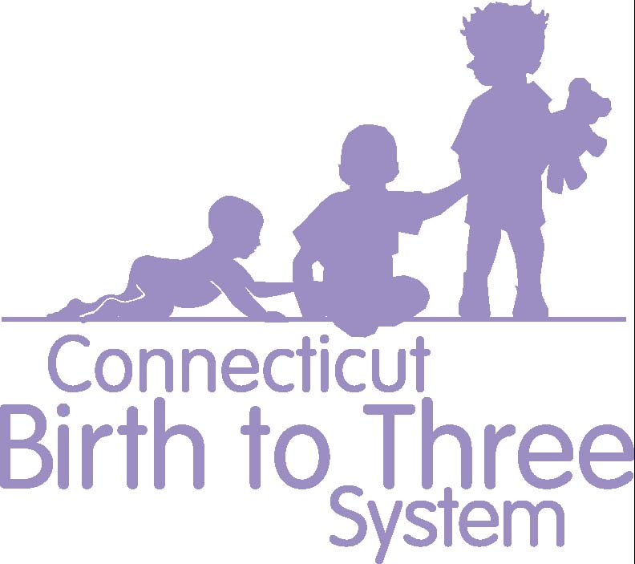

Research Supporting the Birth to Three Practices

The Connecticut Birth to Three System provides Early Intervention Services to meet the unique needs of each child with a developmental delay or disability and the needs of each caregiver to assist in enhancing the child’s development. Among others, three evidence-based practices are recognized in the field to be most effective;
- natural learning environment practices,
- primary service provider approach to teaming, and
- the use of coaching in interactions with parents in order to increase their confidence and competence in facilitating their child’s developmental outcomes.

In 2008 a national panel of experts developed key principles for providing Early Intervention Services (EIS).
Infants and toddlers learn best through everyday experiences and interactions with familiar people in familiar contexts.
- All families, with the necessary supports and resources, can enhance their children’s learning and development.
- The primary role of a service provider in early intervention is to work with and support family members and caregivers in children’s lives.
- The early intervention process, from initial contacts through transition, must be dynamic and individualized to reflect the child’s and family members’ preferences, learning styles and cultural beliefs.
- IFSP outcomes must be functional and based on children’s and families’ needs and family-identified priorities.
- The family’s priorities, needs and interests are addressed most appropriately by a primary provider who represents and receives team and community support.
- Interventions with young children and family members must be based on explicit principles, validated practices, best available research, and relevant laws and regulations. (1)

The paradigm has shifted to a contextual and consultation-based delivery of supports and services to the family and for the benefit of the child. (2) It has been demonstrated through research that parents are key to enhancing their children’s development. (3)

Research syntheses of parents’ interactional behavior with their infants and toddlers and young children with disabilities show that responsiveness to children’s behavior has development-enhancing effects. The particular characteristics of a responsive interactional style that are most important in terms of explaining positive child outcomes are the ability to perceive and interpret a child’s behavior as an intent to interact or affect an environmental consequence, caregiver contingent responsiveness in amounts proportional to the child’s behavior, and joint and reciprocal turn taking during interactive episodes. Behavioral interventions that focus specifically on caregiver awareness and accurate interpretation of, and contingent social responsiveness to, children’s behavior have been found to be most effective. (4)

Coaching practices used in early intervention focus on reflection to increase the caregiver’s awareness, analysis, and generation of alternative ideas to support their child. Through coaching, the early interventionist also shares information and models techniques and strategies based on best available research, in order to increase the caregiver’s competence. (5,6). There is broad consensus in the field that caregiver-implemented interventions are effective. (7,8)

Guidance from the Early Childhood field states that practitioners should use coaching or consultation strategies with caregivers or other adults to facilitate positive adult-child interactions and promote child learning and development. (9). A scoping review of research on coaching in Early Intervention focused on use of problem solving and reflection in order to build caregiver capacity. (10)

Research supports that children need incredible amounts of goal-directed, contextual practice and repetition for learning to occur. (11,12). This can only happen in the natural environment, when carried out throughout the everyday activities of the family and child.

This does not happen during an hour a week of intervention when the therapist is present. Without increased caregiver competence there will not be enough carry-through in everyday activities and opportunity to maximize child outcomes.

The primary service provider (PSP) approach to teaming is used in early intervention to support families of infants and toddlers in achieving the outcomes established in the Individualized Family Service Plan (IFSP). Using this approach, a team of professionals working together provides assessment, intervention, and consultation for the benefit of the child. One member of the team, serves as the PSP and functions as the primary liaison between the family and other team members. The PSP receives consultation from the other team members and may use adult learning strategies, eg, coaching, as a way to interact with and teach other team members, including the family and caregivers. (13)

The use of a primary service provider/primary coach minimizes the negative consequences of having multiple and or changing practitioners. (14)

Research supporting a primary service provider approach includes:
- A 2004 national report by Bruder and Dunst on helpfulness of early intervention, 96% of the time parents with one provider rated him or her helpful , 77 % of the time parents with two providers rated them as helpful, and 69 % of the time parents with three or more providers rated them as helpful. (15)
- Parent and family well-being was positively affected by a family-centered early intervention approach and negatively affected by early intervention service intensity. (16)
- A review of literature found that families with multiple providers showed increased parental stress and confusion. Also noted was that having multiple providers resulted in a significant number of families having unmet needs , especially for children with severe disabilities. (17)
- A study of 190 infants and families receiving 1 year of Early Intervention Services reported that parents had less parental stress with one provider vs. multiple providers. Of significant interest was that the developmental outcomes for these infants was also better when served by a single provider vs. multiple providers. (18)
- A pilot study by Shelden and Rush looked at an experimental group of children and families receiving Early Intervention Services based on Primary Service Provider teaming using a coaching interaction style vs. a control group receiving services from multiple independent providers. The results showed that children and families receiving PSP/coaching received fewer service hours and still met IFSP outcomes more often than did the control group. Children in both groups showed developmental progress with no differences in the amount of progress noted between the groups. (19)

(1) Workgroup on Principles and Practices in Natural Environments, OSEP TA Community of Practice: Part C Settings. (2008, March). Agreed upon mission and key principles for providing early intervention services in natural environments. Retrieved from http://ectacenter.org/~pdfs/topics/families/Finalmissionandprinciples3_11_08.pdf
(2) Adams, R. C., Tapia, C., Council on Children With Disabilities. (2013) Early Intervention, IDEA Part C Services, and the Medical Home: Collaboration for Best Practice and Best Outcomes. Pediatrics, 132(4), 1073-1088.
(3) Bruder, M. Early Childhood Intervention: A Promise to the Future of Children and Families. Exceptional Children 2010; 76(3): 339-355
(4) Dunst, C. ( 2012) Advances in Theory, Assessment and Intervention with Infants and Toddlers with Disabilities In J.M. Kauffman & D.P. Hallahan (Eds.). Handbook of special education: M.A. Conroy (Section Ed.). Early Identification and Intervention. New York: Taylor & Francis.
(5) Friedman M, Woods J, Salisbury C. Caregiver coaching strategies for early intervention providers: moving toward operational definitions. Infants Young Child. 2012;25(1):62–82
(6) Rush, D. D., Shelden, M. L., & Hanft, B. E. (2003).Coaching families and colleagues: A process for collaboration in natural settings. Infants and Young Children, 16, 33-47.
(7) Akamoglu, Y., & Meadon, H. (2018). Parent-Implemented language and communication interventions for children with developmental delays and disabilities: A scoping review. Review Journal of Autism and Developmental Disorders, 5(3), 294-309.
(8) Roberts, M. Y., & Kaiser, A. P. (2011). The effectiveness of parent-implemented language interventions: A meta-analysis. American Journal of Speech-Language Pathology, 20, 180-199.
(9) Division for Early Childhood (DEC). (2014). DEC recommended practices in early intervention/early childhood special education 2014. Retrieved from http://www.dec-sped.org/recommendedpractices
(10) Lorio, C. M., Romano, M., Woods, J. J., Brown, J. (2020). A review of problem solving and reflection as caregiver coaching strategies in early intervention. Infants & Young Children 22(1), 35-70.

(11) Adolph, K. E., Vereijken, B., & Shrout, P. E. (2003). What Changes in Infant Walking and Why. Child Development, 74(2), 475-97.
(12) Ulrich B. Opportunities for Early Intervention Based on Theory, Basic Neuroscience, and Clinical Science. Phys Ther. 2010;90(12):1868-1880.
(13) Early Intervention Special Interest Group of the Section on Pediatrics, APTA (2013) Fact Sheet: Using a Primary Service Provider Approach to Teaming.Alexandria, VA: Section on Pediatrics, APTA.
(14) CaseTools (2009) Checklist for Implementing a Primary-Coach Approach to Teaming http://fipp.org/static/media/uploads/casetools/casetool_vol5_no1.pdf
(15) Bruder M.B. & Dunst, C.J. (2004) Outcome Interview Data Report.
(16) Dunst C. J., Hamby D. W., Brookfield J. (2007) Modeling the Effects of Early Childhood Intervention Variables on Parent and Family Well-Being. Journal of Applied Quantitative Methods, 2(3), 268-288.
(17) Sloper, P., & Turner, S. (1992). Service Needs of Families of Children With Severe Physical Disability. Child: Care, Health and Development, 18(5), 259-282.
(18) Shonkoff, J.P., Hauser-Cram, P., Krauss, M.W., & Upshur, C.C. (1992) Development of Infants With Disabilities and Their Families: Implications for Theory and Service Delivery. Monographs of the Society for Research and Child Development, 57(6), 1-163
(19) Shelden, M.L., Rush D.D. (2013) A Pilot Study of the Use of Geographically Based Early Intervention Teams Using a Primary Service Provider Approach to Teaming in The Early Intervention Teaming handbook: The Primary Service Provider Approach. Baltimore, MD: Paul H. Brookes Co. (p. 40)

