State Interagency Coordinating Council

October 5, 2020 Minutes
9:00 AM-11:00 AM
Remote Zoom Meeting

ICC Members Present: Leona Adamczyk, Andrea Brinnel, Melissa Roberts, Anne Giordano, Cindy Jackson, Tiffany Allain, Sharon Marie, Shanda Easly, Carol Peltier, Elaine Balsley, Ginny Mahoney, Myra Watnick, Mary Beth Bruder, Alice Ridgeway, Louis Tallarita, Tammy Venenga, Melissa Roberts, Ann Gionet, Kim Nilson

ICC Members Absent: Michelle Rinaldi, Representative Linehan, Senator Abrams

Pending Nominees in attendance: Dr. Milanese (AAP), Karen Pasquel (EHS)

CPAC represented by Adriana Fontaine

Meeting called to order at 9:00 AM by Cindy Jackson ICC Chair
Introductions: ICC members and lead agency staff
Public Comment: Lori Mael, program director of Project Interact presented concerns related to continued decrease in referrals. Section 3.302 child find – there has been a decrease in referral during COVID-19. Social distance and the pandemic has increased the anxiety in families especially for working families. What is the lead agency doing to identify and find infants and toddlers during this time?

Alice Ridgeway: will be addressed late in the meeting as part of the lead agency report

Old Business:
Approval of the June 2020 ICC Minutes: motion to accept and motion seconded, none opposed

New Business:

Dr. Ann Milanese (pending AAP representative) updated the council that CCMC currently directed to do appointment remotely but can do in-person appointments

Parent video testimonials shared regarding remote EI supports.

Family Focused meeting postponed until April 2021

ICC Membership:
Cindy Jackson invited parents to join, referring to Koleen Kerski for application materials or additional information.

Cynthia Jackson

ICC Chair/Provider

Leona Adamczyk

ICC Vice Chair/Parent

Ann Gionet

Dept. of Public Health
Tiffanie Allain
Parent
Kim Nilson
Dept. for Children and Families
Michelle Rinaldi
Parent

Elaine Balsley

ReachOut

Alice Ridgway

Office of Early Childhood
Senator Mary Abrams
State Senator
Shanda Easley
Parent

Sharon Marie

Dept. of Aging & Disabilities Services

Ginny, Mahoney

Dept. of Social Services
Anne Giordano

Education Connection
Carol Peltier

American School for the Deaf
Louis Tallarita
SDE-Homeless Children
Andrea Brinnel

SDE-619

Elisabeth Teller

SARAH-Kidsteps
Vacancy

Early Head Start
Myra Watnick

Rehabilitation Associates, Inc.
Vacant-Dr. A Milanese Pending

American Academy of Pediatrics
Representative Liz Linehan
House of Representatives
Tammy Venenga

Dept. Of Developmental Services
Mary Beth Bruder

UCEDD
Melissa Roberts

Department of Insurance

Provider opening on the council due to the resignation of Elisabeth Teller from Sarah, Kidsteps, Inc. Any provider interested in joining should email Cindy Jackson

Approval process requires Governor Appointment and continues to take a significant amount of time to complete the process.

2 Executive Committee meetings held over since the June ICC meeting:

- Discussion regarding the Lead Agency request for letter of support for OSEP PD training and retention grant. (OEC has since been awarded $750,000 grant)
- Discussion and provider input regarding concerns related to in-person visits and survey questions

Alice Ridgway reviewed the Lead Agency report. Significant discussion and requests for data regarding projected deficit as referrals remain low.

Next Meeting: scheduled for December 14, 2020.

Birth to Three Lead Agency Report
April 6, 2020
Alice E. Ridgway, Part C Coordinator

State Systemic Improvement Plan (SSIP)
Parents will be able to describe their child’s abilities and challenges more effectively
as a result of their participation in Early Intervention.

Responses to COVID-19 PHE
- Interim Remote EI Advisory posted (OEC Memo #5 March 16).
- Webinar #1 held on March 18 with Commissioner Bye and Dr. Mary Beth Bruder, UConn UCEDD Director.
- In person visits prohibited as of (OEC Memo #11 March 23).
- DSS approved Remote EI (#20-16) and Interim remote EI (#20-17) on March 24 back-dated to March 16.
- Webinar #2 held on March 27.
- Information posted on Birth23.org website to support providers implementing Remote EI.
- Eligibility criteria modified to better align with criterion referenced tools (40% delay in 1, 33% 2 or more)
- Governor’s Executive Order 7 O /OEC Memo #14 waives Family Cost Participation fees (March 29).
- Flyer about FCP fees and remote evaluations created and mailed to 950 referral sources (April 3).
- PCG mailing the flyer to families instead of invoices (1st two weeks of April).
- OPM approved expanding GAP to count all children with IFSPs (as of the 1st of the billing month) regardless of services provided or hours on the IFSP. (OEC Memo #14)
- Referrals within 45 days of age 3 are not being sent to LEAs and instead are going to EIS programs.
- UConn UCEDD offering supports to EI programs as needed.
- Exploring how to provider supports after age 3. SPA allows it. SPIDER prevents services being entered after the child’s 3rd birthday and no coding changes can be made plus additional funding will be needed.
- Need to help stabilize EIS programs and the System

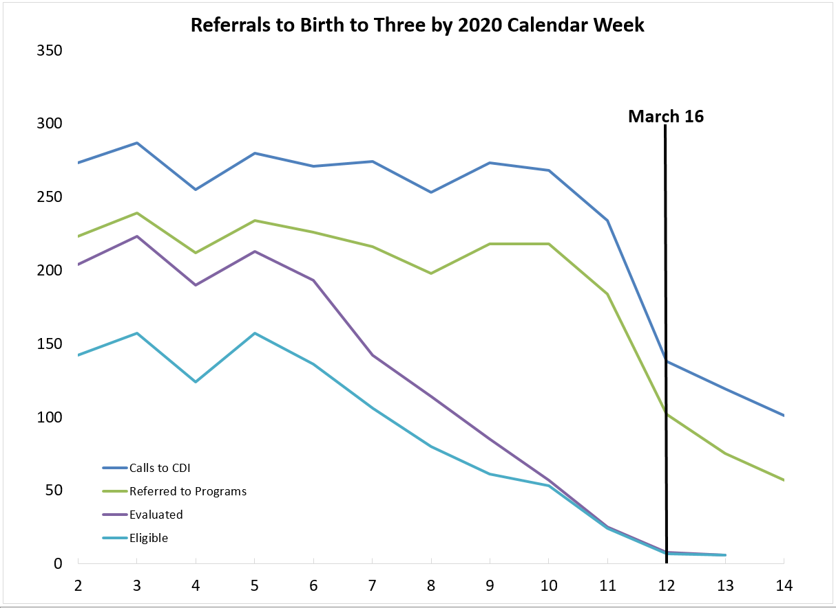
Source: Connecticut Birth to Three Data System as of 4/3 pm. March evaluation data was still being entered.

A number of programs have projected that, services delivered will only be 50% of in-person levels.
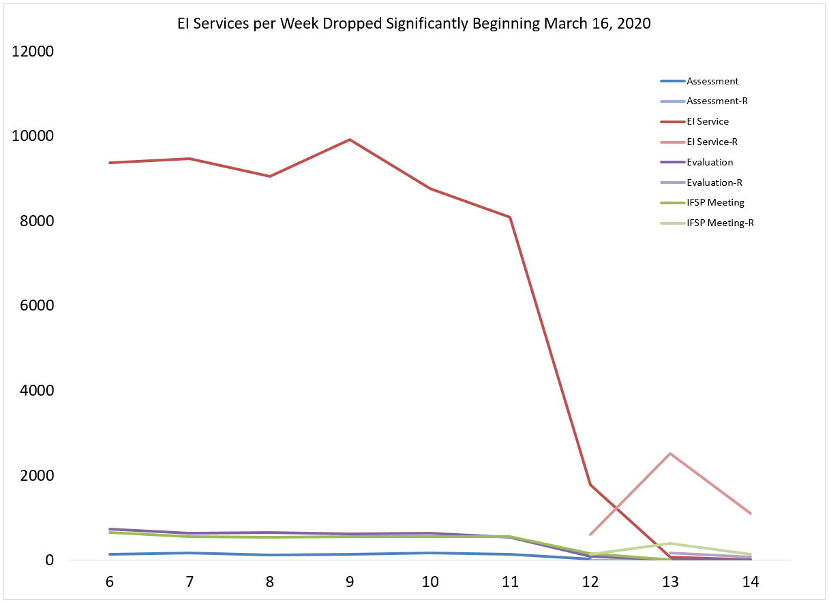
Week 12 is 3/16/20-3/21/20, Week 13 is 3/22/20-3/28/20, Week 14 is 3/29/20-4/4/20 (not all entered yet)

Over Age 3
As of 4/5/20 there were the Birth to Three Data System had 1241 records for eligible children in Birth to Three with a DOB between 3/16/17 and 6/30/17 and an exit date that was blank or after 3/16/20.
Only 930 (75%) had an IFSP in the Birth to Three Data System
Average hours on IFSPs (per month) = 12.5…. Median hours = 5.9
291 had an IFSP calling for 9 or more hours
Average = 29.9 Median= 23.6
639 had an IFSP calling for fewer than 9 hours
Average = 4.6 Median= 4.3
Using 50% for the <9 hour group and 25% for >=9 group the cost per month to support all 906 after June 30 is $438,000 (50% for both groups would be $700,000) One third of the 930 turn three each month so the additional funds needed would increase over time
~$0 - $133,000 during April,
$134,000 - $284,000 during May, and
$285,000 - $438,000 during June

SSIP submitted by Nicole Cossette, Part C Data Manager on 3/31 one day early!

Education and Outreach
- Legislative Transition Workgroup report with Commissioner Bye.
- ECI Leadership Development grant – Marybeth to present to providers about upcoming plans for the first cohort
- FY19 Annual Data Report
Draft uploaded for review
Personnel Development
- Rush and Shelden training may be moved to later in the year – currently exploring options
Fiscal Enhancements
- The current SFY 2020 spending is expected to have a surplus of $1M instead of a $1.8M deficit

