State Interagency Coordinating Council

Cynthia Jackson ICC Chair/Provider Corrine Griffin
ICC Vice Chair/Parent Angela Jimenez Dept. of Public Health Tiffanie Allain
Parent
Kim Nilson
Dept. for Children and Families
Michelle Rinaldi
Parent
Leona Adamczyk
Parent
Elaine Balsley Reach Out Alice Ridgway
Office of Eady Childhaod
Lauren Barbosa
Parent
Senator Mary Abrams
State Senator Shanda Easley Parent
Sharon Marie
Dept. of Aging & Disabilities Services
Ginny Mahoney
Dept. of Social Services Anne Giordano Education Connection Carol Peltier
American School for the Deaf
Louis Tallarita
SDE Homeless Children
Andrea Brinnell SDE-6'9
Elisabeth Teller
SARAH-Kidsteps Jennie Shea Early Head Start Myra Watnicl{
Rehabilitation Associates, Inc. Carol Weitzman, M.D. American Academy of Pediatrics Representative Liz Linehan House of Representatives
Robin Wood
Dept. Of Developmental Services
Betsy Howe
UCCED
Melissa Roberts
Department of Insurance

December 9, 2019
9:00AM -12:00 p.m.

BEACON Health Options 500 Enterprise Drive, Rocky Hill

Minutes

ICC Members Present: Cindy Jackson, Corrine Griffin, Leona Adamczyk, Elaine Balsley, Alice Ridgeway, Senator Mary Abrams, Sharon Marie, Ginny Mahoney, Anne Giordano, Carol Peltier, Andrea Brinnell, Elisabeth Teller, Myra Watnick

ICC Members Absent: Angelica Jimenez, Tiffanie Allain, Kim Nilson, Michelle Rinaldi, Lauren Barbosa, Shanda Easly, Louis Tallarita, Jennie Shea, Carol Weitzman, Representative Liz Linehan, Robin Wood, Betsy Howe, Melissa Roberts

The meeting began at 9:25AM.

Introductions:

Cindy Jackson, ICC Chair, welcomed everyone to the State ICC meeting. Council members and members of the public introduced themselves.

Public Comment

There was no public comment.

Announcements: No announcements.

Guest Speaker: Michelle Riordan-Nold, Director, CT Data Collaborative provided power point presentation; they are a not-for-profit agency that provides trainings and workshops to agencies/programs/individuals on how to organize, improve, and use data more effectively. Website is ctdata.org. They can assist with building data platforms, developing data stories. Birth to Three data is on the website under Health tab. Discussed potential opportunities for ICC for quarterly reports geared to specific legislators by town data.

Old Business: October minutes were approved. Discussed Part C annual report distribution. Letters and reports went to Governor and Lt. Governor and all representatives. Senator Abrams sent a letter from her office along with ICC letter and then hand-delivered to 82 legislators from Health and Children’s subcommittees. Senator Nolan, New London, contacted Cindy Jackson to learn more about Birth to Three after receiving report. Andrea Brinnell and Alice Ridgeway updated ICC on Birth to Five initiative. Workgroup report being drafted and final report will be available in January. Elizabeth Teller, Myra Watnick, and Cindy Jackson are also part of the work group.

New Business: Koleen Kerski, who has many years of experience with the Connecticut Birth to Three program was hired and will be taking over responsibilities from Anna Hollister’s position. Corrine Griffin, ICC parent representative will be leaving the ICC. Appreciation was expressed for her time and commitment to the ICC for many years. Other parent representatives may be leaving soon as well due to the age of their child (12 years old). New parents attended this ICC and they were welcomed to the Education and Outreach subcommittee to learn more from our current parent representatives.

Parent Support Grant Update
Jane Hampton, Training Director of the Connecticut Parent Advocacy Center (CPAC) gave an update on referrals and also Family Connections Facebook page. Facebook page has over 200 participants and seems to be a good resource for parents that they can access. Jane would welcome ideas to include more families in CPAC. Questioned whether all parents being offered CPAC; may be a way to learn more about how to help Birth to Three staff to include them more often.

Lead Agency Update/Fiscal Update

Alice Ridgway, Part C Director-Office of Early Childhood (OEC)-Birth to Three System gave the lead agency update (see attached)

Education and Outreach:
Koleen Kerski started on 11/25/19, replacing Anna Hollister. Legislated Transition Workgroup being drafted last meeting in December. There is a question about possibility/challenges of Part C extending over the summer for Part B eligible children turning 3 between 5/1-8/31

Personnel Development:
Family Cost Participation Form Video completed and online. Rush and Sheldon TA teams nearing completion of their 6 months. 20 interventionists graduating in December from Early Interventionist Specialist intensive yearlong course at UCONN.

Fiscal Enhancements:
RFP received 38 submissions; 36 comprehensive EIS, 2 were DHH support providers only. Scoring will be complete next week, then towns assigned by rank, and with approval by Commissioner Bye. Notification to successful bidders planned for 12/23. Procedure change 1/1/20 to reimburse programs for DAS contracted Spanish interpreters at Evaluations and Assessments. $200,000 impact covered by PDG grant FY19-20. Procedure change to pay statewide DHH programs $120 visit outside of local towns effective back to 7/1/19.
Two of three agreed to be statewide and open for referrals (projected impact <$100,000). Currently projecting
$1,782,394 deficit for FY 19-20, down from $1,830,830 in October. Insurance receipts and family cost receipts coming in higher than originally estimated.

Committee Reports

Legislative/Fiscal Committee: (Co-Chairs: Myra Watnick & Elaine Balsley)
h
Senator Abrams reported discussion about February Birth to Three Forum at the Capitol. Date would need to be set, and her office will coordinate around all the stakeholders. Forum would be about an hour, with a focus on 25-year anniversary and benefits of program, growth, fiscal impacts for state in terms of reducing special education services needed at age 3. Would be very helpful if parents contacted their representatives and asked them to be there. All parents and children are welcome as well. Providers should get the word out when the date is set. Discussed parent cost and how that impacts the system. Concerns regarding PCG billing at 200% for services and how parents are perceiving that cost, making it difficult for program staff.

System Support/ Professional Development: (Co-Chairs: Anne Giordano & Elisabeth Teller): Discussed staffing challenges, mini-training blogs and accessible resources. Follow up on ABT ongoing training and support. New group should be starting in June.

Communications/Education/Outreach Committee: (Co-Chairs: Corinne Griffin & Carol Peltier):
Current parent members discussed their experiences on the council with potential new members. Talked about next steps in terms of membership, as well as diversity.

2020 Meeting Dates:
February 10th, April 7th, June 1st, October 5th, and December 14th.

NEXT State ICC MEETING: Monday, February 10, 2020 at BEACON, 500 Enterprise Drive-Suite 3D (Hartford Room), Rocky Hill, CT. Please RSVP to Chris.Beott@ct.gov

Birth to Three Lead Agency Report
December 9, 2019
Alice E. Ridgway, Part C Coordinator

State Systemic Improvement Plan (SSIP)
Parents will be able to describe their child’s abilities and challenges more effectively
as a result of their participation in Early Intervention.

Education and Outreach
- Koleen Kerski started on 11/25/19!
- Legislated Transition Workgroup report being drafted for last meeting in December.
- QUESTION: Challenges with extending Part C over the summer as an option for families of children who are eligible for Part B and turn three between 5/1 and 8/31?

Personnel Development
- Family Cost Participation Form Video completed and online
- Teams participating in Rush and Shelden TA are nearing completion of their six months of TA.
- 20 interventionists are graduating in December from the Early Interventionist Specialist yearlong course at UConn. This is an intensive program addressing best practices in early intervention.

Fiscal Enhancements
- RFP received 38 submissions; 36 comprehensive EIS, 2 were DHH support providers only. Scoring should be completed next week, then we assigning towns by rank and approval by Commissioner Bye. Still planning to be able to notify successful bidders by 12/23.
- Procedure change effective 1/1/20 to reimburse programs for DAS contracted Spanish interpreters at Evaluations and Assessments - impact projected at ~$200,000 but covered by PCG grant for FY19-20.
- Procedure change to pay statewide DHH support programs $120 per visit outside of local towns effective back to 7/1/19. Two of the three agreed to be statewide and open for referrals, impact projected at <$100,000
- Currently projecting a $1,782,394 deficit for FY 19-20, which is down from $1,830,830 in October.
- Insurance receipts and family cost participation receipts are coming in higher than originally estimated.
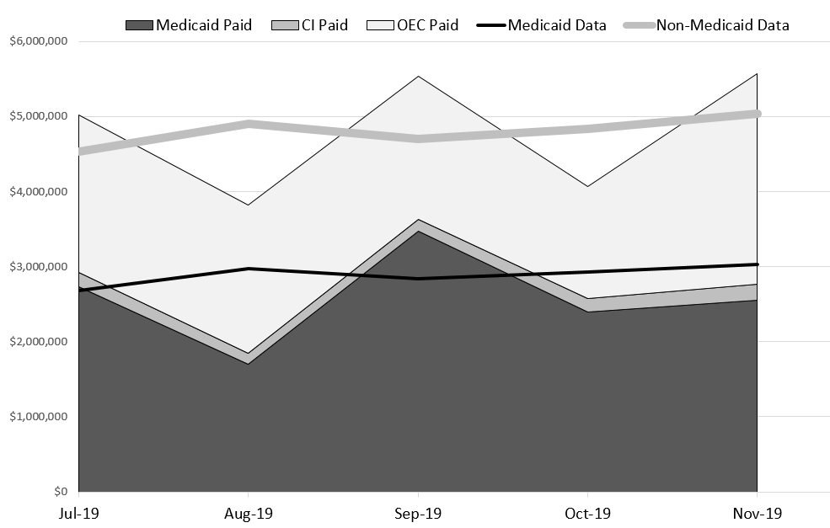

SPP/APR Summary by Nicole Cossette, Part C Data Manager
- New interface not open until 1/1/20. Added Cindy and Myra as viewers, can add more if interested. Once opened and entered will be a quick turn-around.

