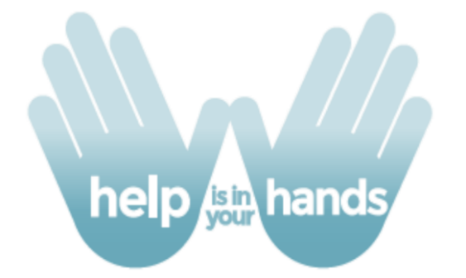
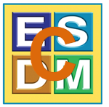
www.helpisinyourhands.org

To assist providers and families with distance learning we would like to share on-line videos for families of very young children with social communication challenges. Modules include narrated video lessons and examples of real parents and children interacting in their own homes, with suggestions for follow-up activities parents can try.
Strategies come from our research on effective practices used in parent implementation of the Early Start Denver Model. Modules can be accessed via smart phones, tablets, and computers.
These materials are publicly available to all families and providers at https://helpisinyourhands.org
Accessing the Modules:
- Sign up using the link above: Click Don’t have an account? Create one now.
- Logging in will provide access to the 4 Help is in Your Hands modules:
  - Increasing Children’s Attention to People
  - Increasing Children’s Communications
  - Joint Activity Routines to Increase Your Child’s Learning and Communication
  - The ABCs of Opportunities for Learning
- Additional provider-specific resources can be found at: helpisinyourhands.org/provider/resourcecenter
  - These materials can be accessed after creating an account at the “main” helpisinyourhands.org page.
  - Materials include: a self-guided training syllabus, webinars covering all the content, supplemental video tips for providers, and all HIIYH handouts
A Product of the C-ESDM Project
Developed by Sally Rogers and Aubyn Stahmer
With support from the Institute of Education Sciences, the MIND Institute, and the 3C Institute
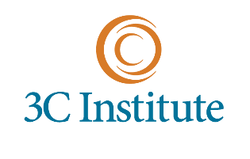
In collaboration with research and community partnerships at the University of Pennsylvania, Children’s Hospital Colorado, and The University of Alabama.

