***Follow the instructions in the table below once for setting up training plans for CT Birth to Three. Instructions are in 3 separate Sections in this document, depending on your needs:
New Users | You will need to Create An Account (Page 1-3). Next Add Yourself to Training Plans (Page 4-6). When you go to home page or login at a later date, you will click Your Learning tab at top of page and then will see Your Training Plans.
Previously Registered Users | You will need to Login. Then follow instructions for How To Verify Your Group and Add Your Training Plans (Page 7-14).  When you go to home page or login at a later date, you will click Your Learning tab at top of page and then will see Your Training Plans.

New Users: How to Create an Account
Step #1 – Go to Train Connecticut website at https://www.train.org/connecticut/
Step #2 - Click “Create an Account”
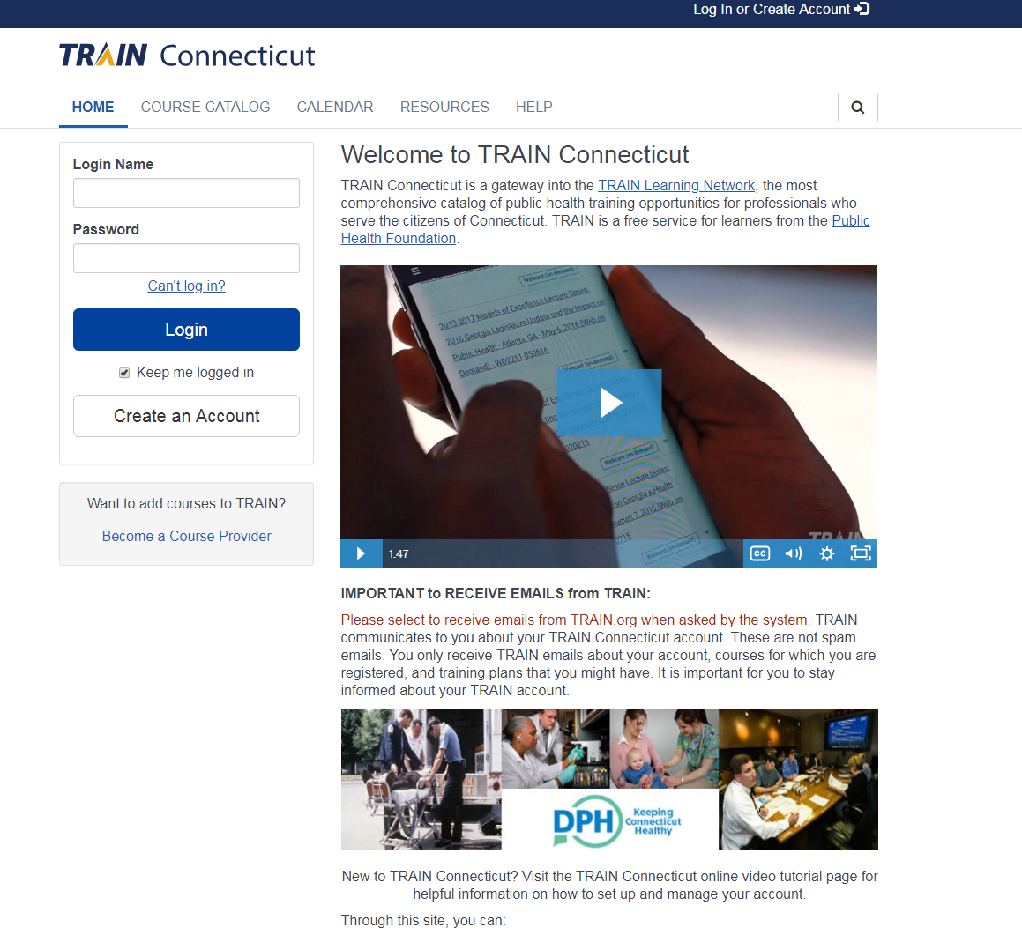
Step #3 – Complete the next few screens with registration information and your information.
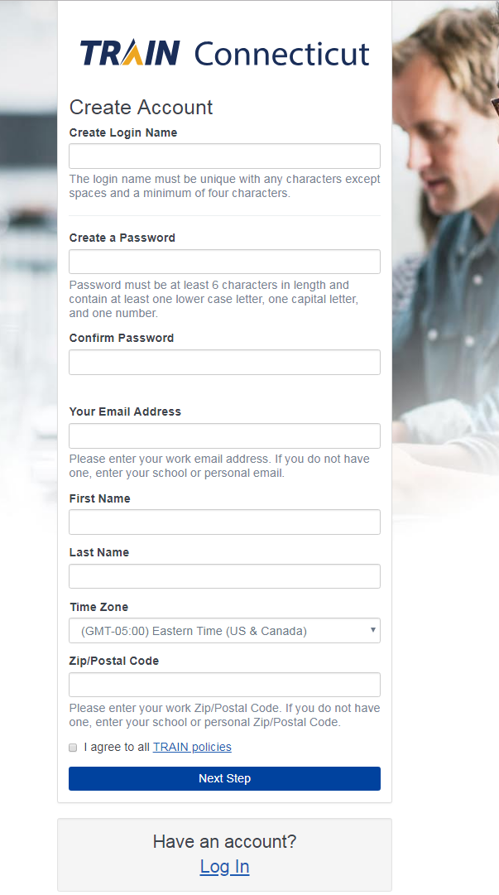
Step #4 – After entering your information, be sure to check “I agree to all TRAIN Policies” box. Then click “Next.
Step # 5 - Then select the “CT Birth To Three” group.
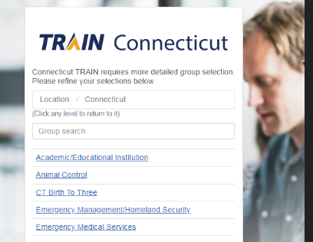

Step #6 – Click “Confirm these selections”.
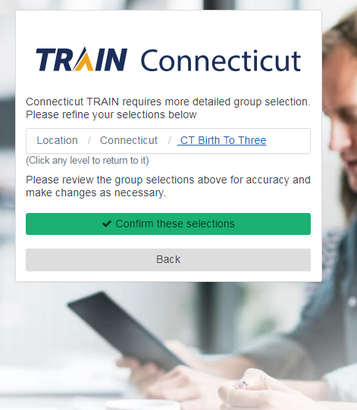
Step # 7 – Click “Finish Creating your Account” button. Continue to pages 4-6 of these directions, How to Add Yourself to Training Plans.
How To Add Yourself To Training Plans

Step #1 – Log in or go to “Home” page (if already logged in).
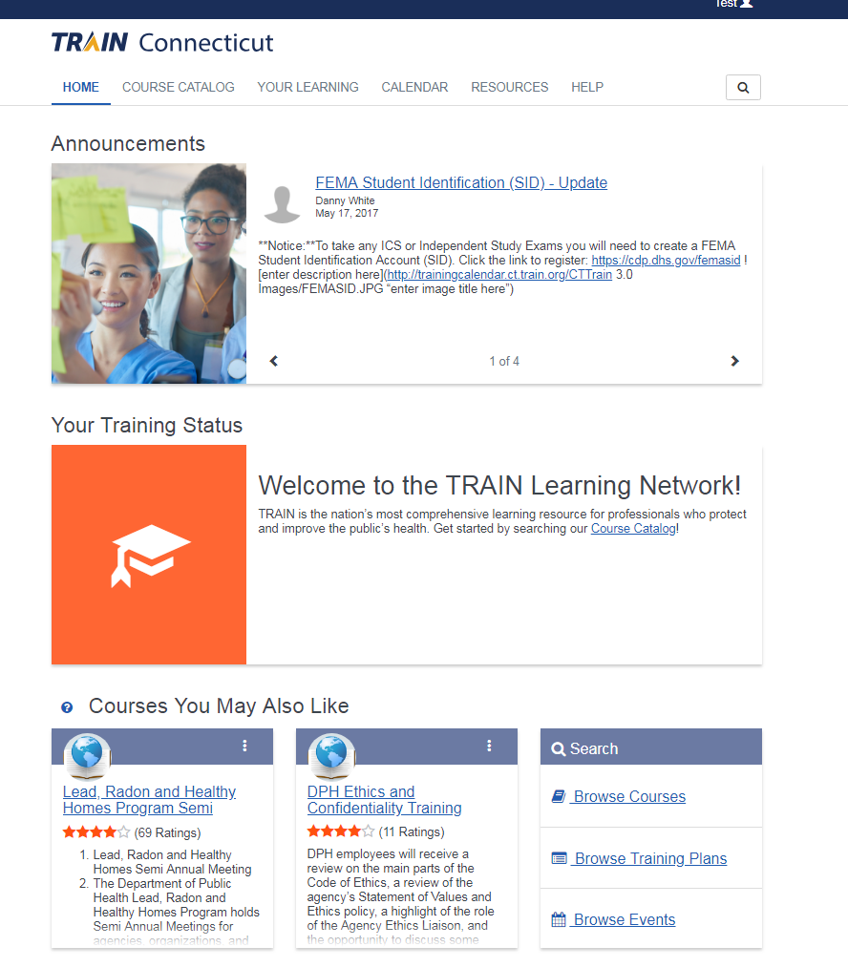

Step #2 – Click “Browse Training Plans”.
Step #3 - Type “CT Birth to Three” in the search box here. You will see the training plans listed below.
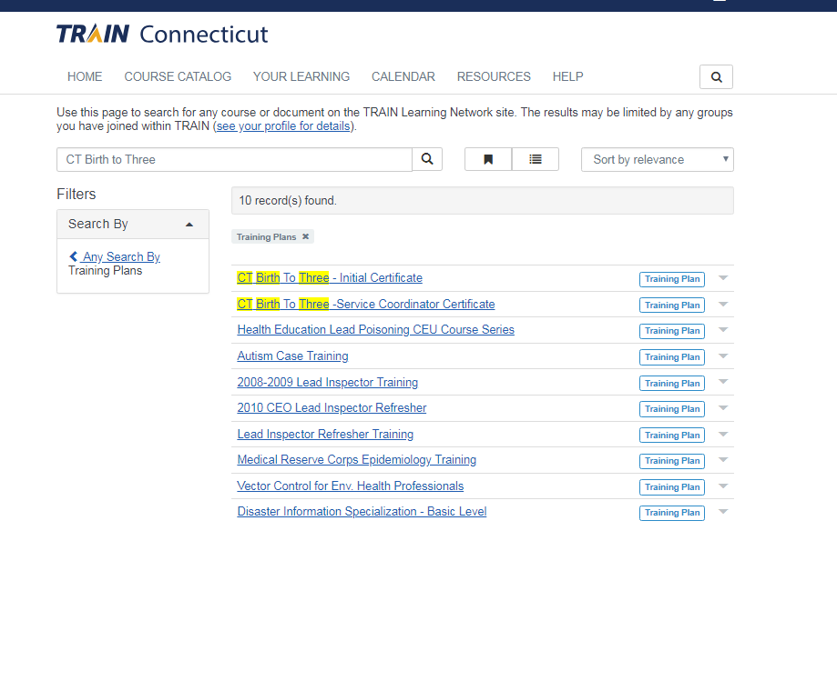Step #4 – IMPORTANT: first click the link for the “CT Birth To Three - Initial Certificate”. You must add yourself to this training plan first. If you are pursuing the Service Coordinator Certificate you will add that AFTER you add the Initial Birth to Three Certificate training plan. The Initial Certificate is a pre-requisite for the Service Coordinator Certificate.

Continue to Step 5 on next page

Step # 5 - Click “Register” to add yourself to the training plan.

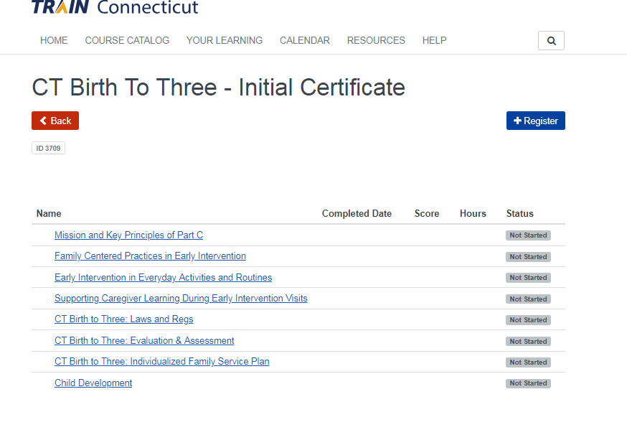
Step # 6 – You are done registering for the Initial Certificate training plan.
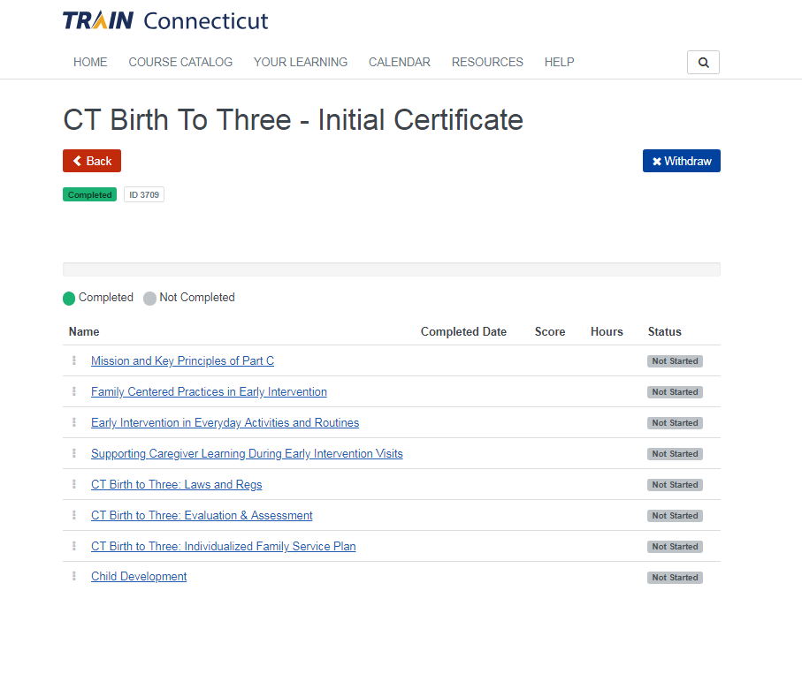
Step #7 – If you are planning to pursue the Service Coordinator Certificate click the Back button and additionally add the “CT Birth to Three – Service Coordinator Certificate” training plan.
**Once your training plan(s) are added, go to TRAIN CT HOME page (“Back” > “Home”), click on Your Learning tab at top of page, and then you can see Your Training Plans (click on training plans) to see a list of all required modules.
Existing User: How to Verify Your Group and Add Your Training Plans

Step #1 – Log in and click on your name in the upper right-hand corner. Select “Your Profile”.
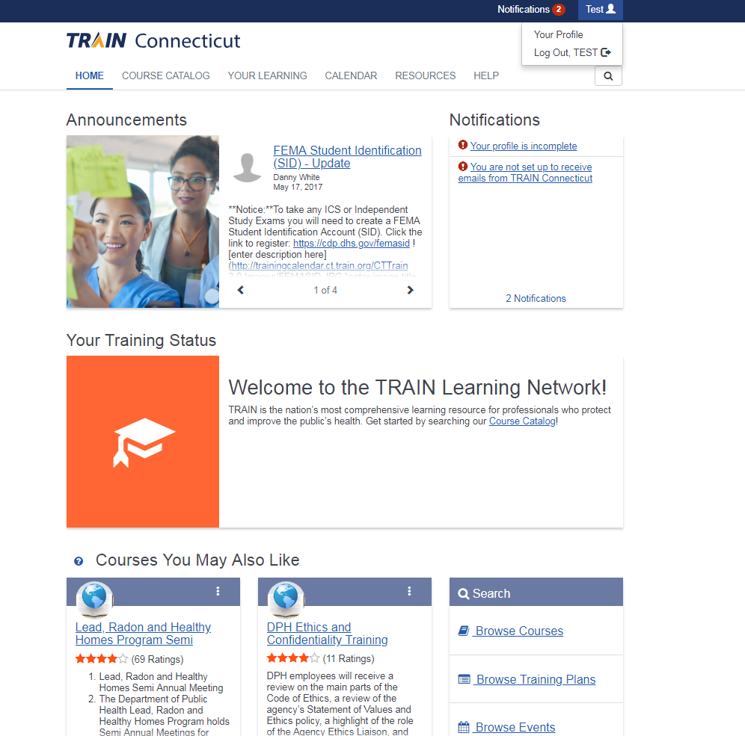

Step #2 – You may see “CT Birth To Three” as your group. If you DO see CT Birth to Three, select “Close”, go to TRAIN CT Home page and follow steps in these directions (page 4-6) to add your training plans.
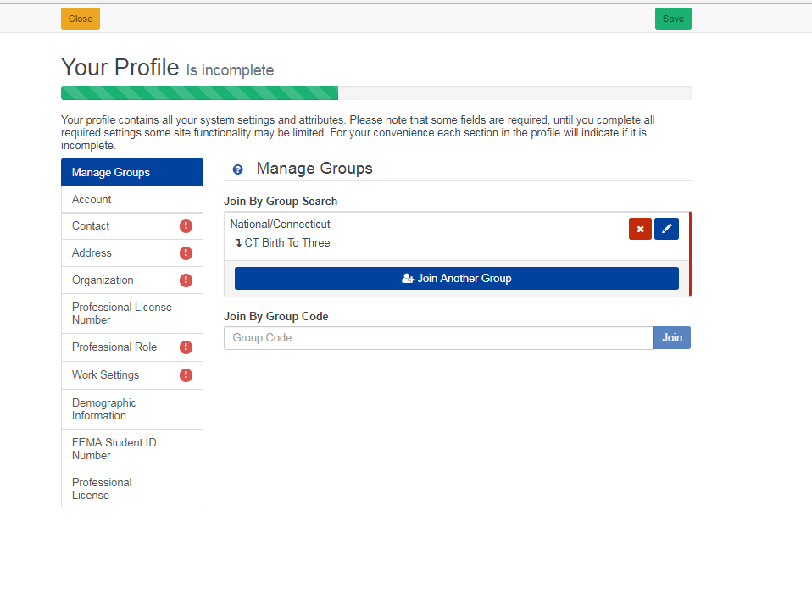
If you DO NOT see CT Birth To Three as your group, go on to step #3 below.
Step #3 - Click the edit button (pencil)
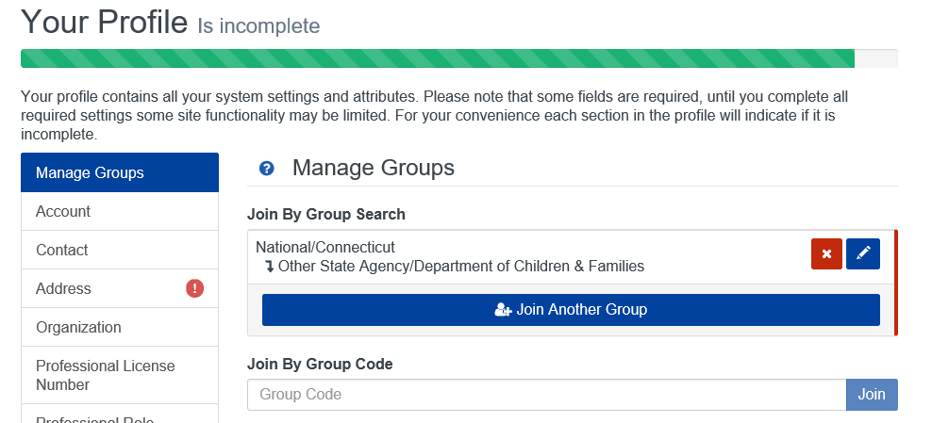

Step #4 - Click on “CT Birth to Three”
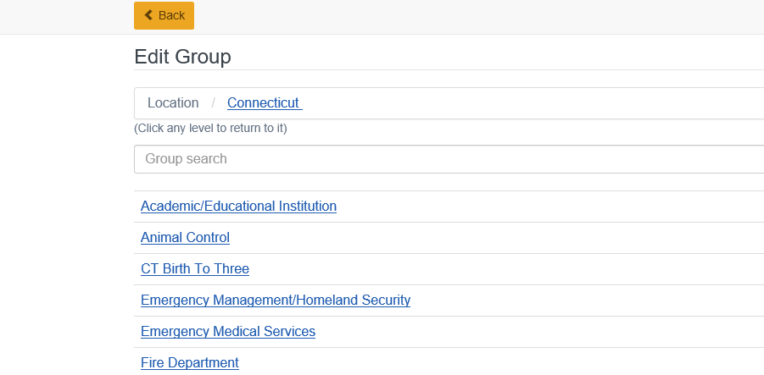

Step #5 – Click “Confirm these selections”, then “Confirm Group Selections” buttons.
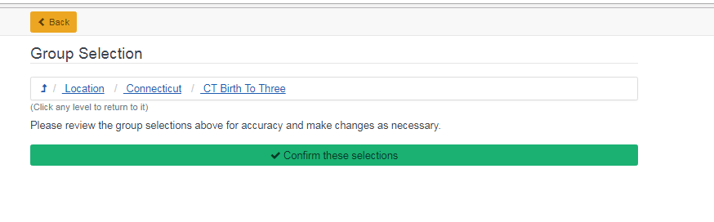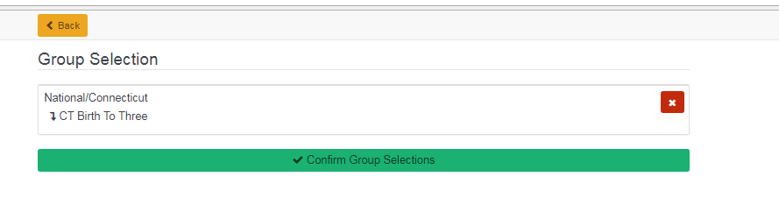

Step # 6 - You should now see “CT Birth To Three” listed on your profile. Click “Save” on top right of page.
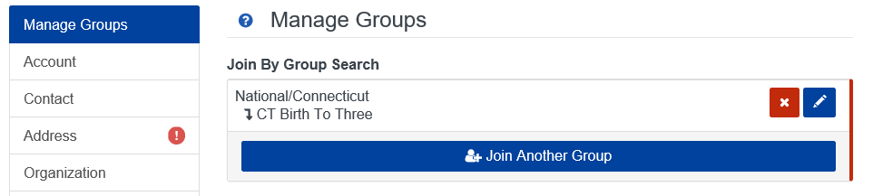

Step # 7 - Click “Close” and return to Home page for TRAIN CT – follow next instructions to set up Your Training Plans.
Step # 8 – Click on “Training Plans” (For some users, if “TrainingPlans"is not visible where black arrow is pointing, this Search box may be located lower on the page, on right.)
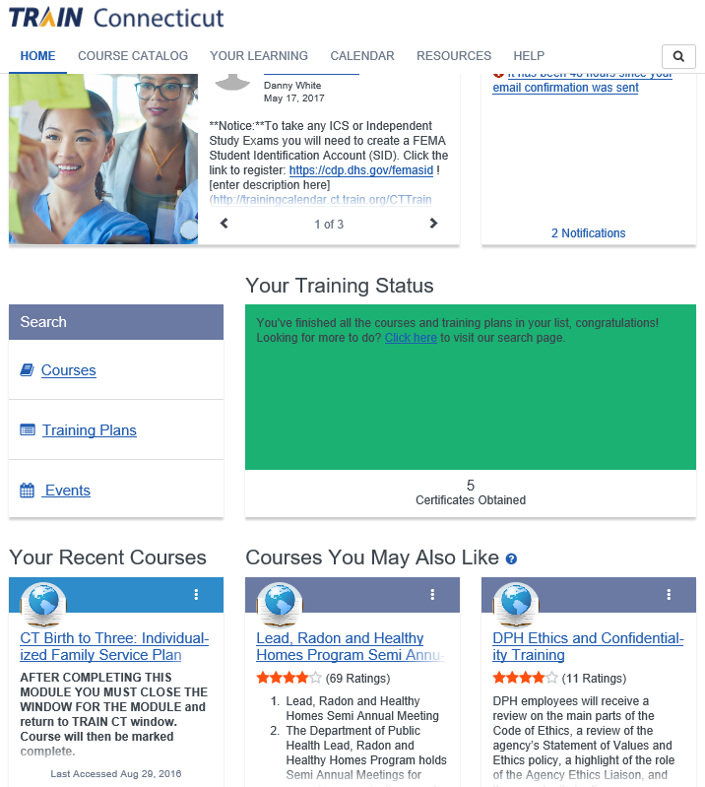

Step # 9 – Click on “CT Birth to Three: Initial Certificate”
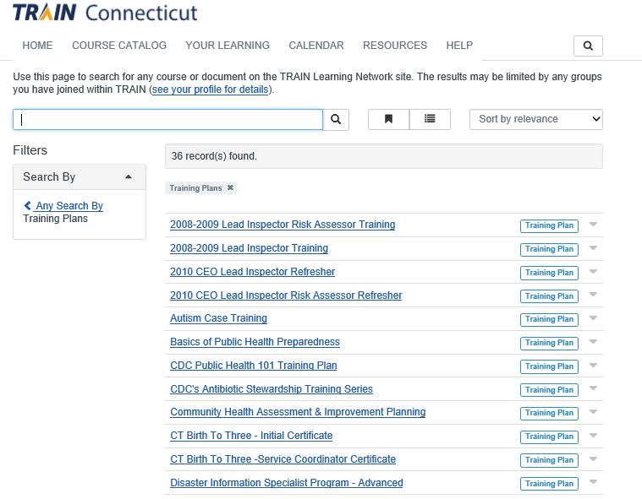
Step # 10 – Click “Register”
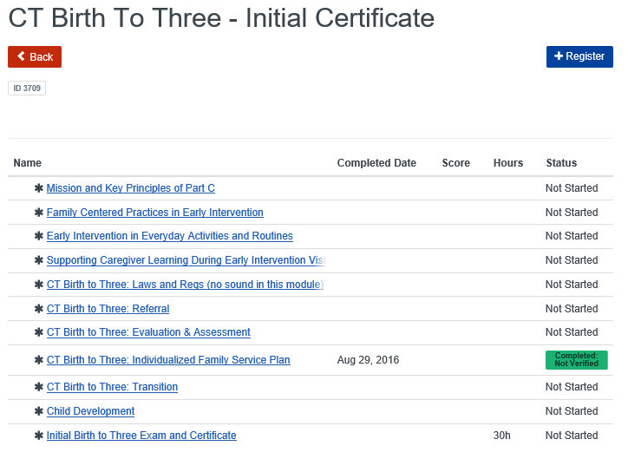
Step # 11 – Click “Back”
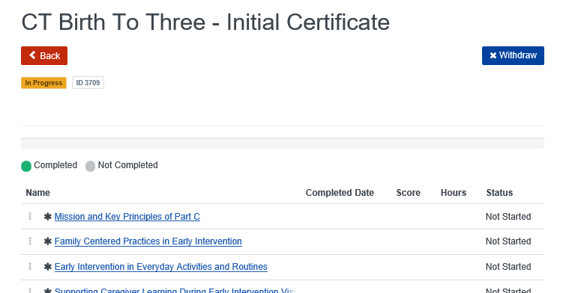

Step # 12 – As appropriate, Click “CT Birth to Three – Service Coordinator Certificate” by repeating Steps 10 & 11.
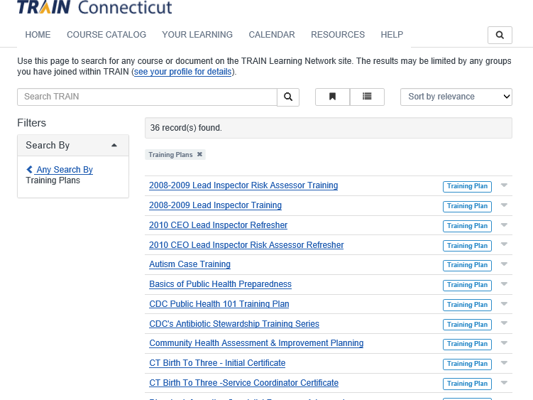

Step # 13 – After setting up Your Training Plans and clicking “Back” you will see this page. Click “Home”.
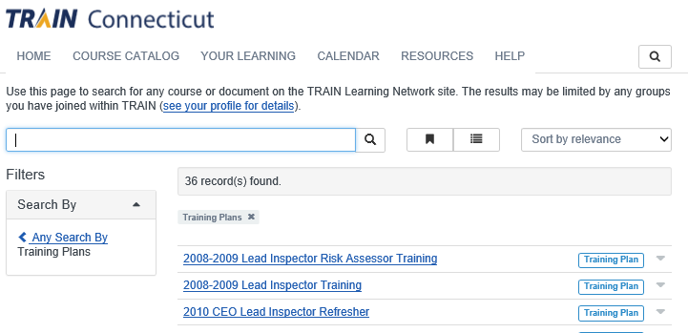

You have now set up Your Training Plans and may access them here or here (Your Learning>Your Training Plans):
