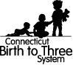 | 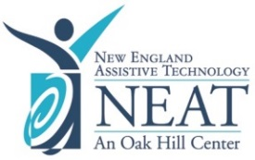
NEAT Assistive Technology Services available to Birth to Three Providers at no charge

NEAT Service | NEAT  Purchasing Assistance | NEAT Lending Library  Short Term Loans | B23 Inventory  Long Term Loans of Assistive Technology Devices
 | 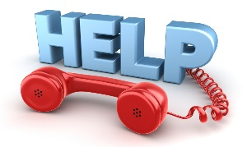 | 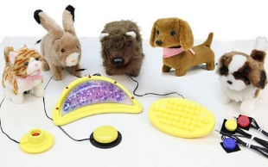 | 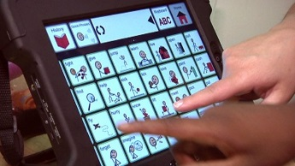 | 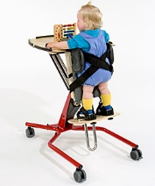
 | AT Inquiries |  | iPads for Communication | Adaptive Equipment
Service Description | Exclusive phone, e-mail, or video conferencing available to access information and resources from our assistive technology staff regarding the selection of appropriate and cost-effective devices. | Free Access to the AT Lending Library includes (but not limited to): switches, adapted toys and communication devices (non-iPad) and so much more! | Free access to the Birth to Three Adaptive Equipment Inventory, managed by NEAT’s Equipment Restoration Center (ERC). Both iPads (dedicated) for communication purposes as well as adaptive equipment are available for loan.  NEAT also partners with third party vendors (e.g., Rifton) who provide trial periods of their equipment for a specific loan period.
Point of contact | 860-243-2869  NEAT.B23@oakhillct.org
Forms required | Contact NEAT  No forms necessary | Contact NEAT or download the  NEAT Lending Library Loan Form | Contact NEAT or download the following forms  Long Term Loans  Birth to Three Loan Agreement Form (3-14)  Trial of Vendor Equipment  Birth to Three Loan Agreement Form (3-13)  These forms, as well as the Birth to Three Procedure on Assistive Technology, can be found at the CT Birth to Three website.
Additional  Forms | You will NOT need to submit CT. Birth to Three Form 3-11 to NEAT  You will submit Form 3-11 to the CT. Birth to Three System when seeking reimbursement for assistive technology  Refer to CT. Birth to Three Assistive Technology Procedure

