Title: | INTAKE
Purpose: | Describes the single point of intake for Birth to Three referrals under Part C of IDEA and the capacity to track non-eligible children’s development.

Overview

Child Development Infoline (CDI) is the single point of entry into the Connecticut Birth to Three System via a toll free telephone number, or fax or website referral form. Within the United Way of CT 2-1-1 organization, CDI handles all calls coming into the 1-800-505-7000 line, including calls for Birth to Three, and a variety of other supports. Only CDI can enroll children in the Birth to Three System and assign a case number

Availability of CDI Staff

CDI staff accept referrals and other calls Monday through Friday from 8 a.m. to 6 p.m. The CDI voicemail system is available 24 hours a day, every day. The outgoing message indicates when the office is closed, e.g., holiday or extreme weather conditions. Callers may leave their name and number to receive a return call. Their outgoing message names Birth to Three and the other programs and services accessed via CDI.

Processing a Contact

To best match the caller’s needs and the child’s age, CDI staff begin the intake process by triaging calls across all of the programs, services and supports for which they are the access point. This includes Help Me Grow, In-Home Supports, Birth to Three, Early Childhood Special Education, and Children and Youth with Special Health Care Needs. Every contact to Child Development Infoline (CDI) about a child younger than 34.5 months is considered a Birth to Three referral only when a developmental concern is identified.

Birth to Three Referrals

For referrals triaged into to the Birth to Three System, CDI staff gather, confirm, record and share information.

Confirm:
- the parent’s or legal guardian’s interest in proceeding with the referral when it was made by anyone other than the child’s parent or legal guardian.
  - If a family has no telephone or does not respond to messages left by CDI staff, a “request for contact” letter is sent to the family asking them to call CDI to complete the intake for Birth to Three, if interested. If CDI is unable to reach the family or if the family declines the Birth to Three referral, a disposition letter is sent to the referral source indicating the outcome.

- that the child lives in the state of CT. The Connecticut Birth to Three System is not required to provide Part C early intervention services to a child who is also receiving Part C early intervention services in another state if that child and their family are only temporarily visiting Connecticut. If the family is in the process of moving, CDI informs them to call back when they do live in Connecticut. This does not apply to children who:

  - are homeless or whose family is highly mobile (e.g. migrant workers) or
  - are displaced by a catastrophic event such as a hurricane or flood, or
  - are wards of the state, or who
  - reside on an Indian reservation.

Gather and Record Information about:
- the child’s current abilities from the referral source and/or parent.
- the child’s birth history and relevant medical information
  - whether an audiological exam has been completed,
  - developmental, social-emotional or autism screening plus results when available.
  - If the child has a diagnosed condition that affects eligibility, CDI staff will record that diagnosis prominently in the Notes section of the Referral concerns in the Birth to Three data system
- the child’s primary health care provider and other medical providers.
- language(s) spoken and read in the home.
- If questions arise related to eligibility, staff indicate that eligibility is determined at the program level.

CDI informs Families that:

- the evaluation is provided at no cost to their family
- if families do not indicate a choice of program from among those serving their town, CDI uses a rotation process to identify the program that will complete the initial evaluation or assessment,
- all of the programs are comparable in terms of quality of services, types of staff employed, and ability to schedule the evaluation and services in the home or other natural environment.
- the assigned program will contact them within a few days to schedule the initial appointment, and offer a brief description of the visit
- provide the website address to Family Handbook Guide I which describes the evaluation process and their parent rights under Part C of IDEA
- provide the website address to the Home Visiting video at youtu.be/8fOJGmIdj0c
- If a family has additional questions, CDI addresses them.
- they can call CDI back if they have any questions or concerns, have not heard from a program as expected, or are unhappy with the selected program

Steps taken once referral has been assigned to a program:
- CDI sends the family a parent Welcome packet that includes:
  - the name and contact information for the Birth to Three program that will schedule their evaluation visit
  - a list of all the programs serving families living in their town
  - a “Welcome to the Birth to Three System” letter that includes a Family Handbook Guide I website link
  - additional resources
- CDI sends the referral source a confirmation letter if the referral was made by someone other than the parent or guardian that includes:
  - the name, address, contact person and phone number of the program that will determine the child’s eligibility.
Note: If a child is referred who is already in process with Birth to Three, a letter indicating that the child has already been referred will be sent to that referral source.

Parent Requests for Specific Programs
If a parent requests a specific program that serves their town and is open to new referrals or transfers, CDI will note this in the database and assign the referral to that program. When a parent makes a special request listed below, CDI takes these actions before assigning the referral to any program.

Parent requests services… | CDI action step(s)
from a program that does not serve their town | Contact the Birth to Three administration for approval for special circumstances.
in both the town of residence and at the child’s early care setting in another town outside of the program’s catchment area | Offer the parent a choice from among all program(s) that serve both towns. If there are none, CDI will identify a program that can accommodate the request. CDI tells the parent that they must actively participate and be present during the eligibility determination and at least some service visits regardless of the location.
be provided by a program that serves their town but is not currently accepting referrals via rotation | Contact the program director to learn if a new referral can be accepted. If the program is not able to accept the referral within five calendar days, the referral will be sent to the next available program in the rotation cycle.

Family or Child Special Circumstances

- If CDI learns that the family is homeless, they will enter that information in the data system. This will alert the receiving program that the family needs to be contacted as soon as possible before there may be a change in their address, and to take extra measures to ensure completion of the evaluation, assessment and IFSP process if the child is found to be eligible. For more information see the procedure entitled, “Children who are Homeless”.

- If the child is hospitalized and not available, CDI staff records “Referral on Hold” in the notes section of the referral concerns screen. (Only CDI staff may use this option.)

- If the child being referred has a diagnosed hearing loss that meets Birth to Three eligibility criteria CDI will work with the family to identify a program that serves the town where the family lives. If the family has a preferred approach to learning language CDI may discuss the different programs that specialize in hearing. CDI will send families a handout created by Connecticut’s Early Hearing Detection and Intervention (EHDI) workgroup and give the family information on “Guide By Your Side”.

- If the parent or referral source indicates that the child has been diagnosed with an Autism Spectrum Disorder, failed a screen for Autism, or if there are any concerns regarding autism and the child is 12 months or older, CDI offers information about the programs that specialize in autism, in addition to the general programs that serve their town.
• For children 12 months and older, if there is a concern about autism the family can be referred to a program that specializes in autism, regardless of whether the MCHAT- RF has been administered.
• CDI will ask if the child has a sibling who has been diagnosed with autism as there is more risk if a sibling has already been diagnosed
• The autism concern box on the referral should be checked regardless of age or who expressed concern
• Parent readiness and choice are still strong values for selecting a program

CDI also directs the parent to the online location of the Birth to Three Service Guideline #1, Autism Spectrum Disorder for more information. CDI forwards the referral to the parent’s chosen program.

- CDI redirects callers whose intention is to refer children within 45 days of their third birthdays by offering the following:

  - information about the responsible local school district to seek an evaluation for early childhood special education, including the LEA address and phone number.
  - the web site location for the State Department of Education’s Form ED621, “Referral for Special Education” or mail a copy
  - information about supports available from the CT Parent Advocacy Center (CPAC) including their website address.

Re-entering the Birth to Three System

Families re-enter Birth to Three for a variety of reasons. Most will be treated as new referrals. Sample scenarios are listed below. In most cases CDI will refer the family back to the program that did the previous evaluation or provided services unless the parent requests a different one.

For children who were never evaluated
If the family contacts the EI program within one month of the date when it was determined that the family declined the evaluation or the program was unable to contact the family, the determination data can be changed to Pending by the program.

If the family or another referral source contacts CDI, after the one month return period, a new referral will be created.

For children who were not eligible
If it has been less than one month since the determination was made, the referral source should be told that they need to wait a month and call CDI to make a new referral.

If there is a new diagnosis or information that warrants a re-determination, families do not need to wait and referral sources should contact CDI to make a new referral. In this case programs must email CTBirth23@ct.gov for prior authorization to complete an evaluation within one month of a previous evaluation.

If during the tracking and monitoring process (Help Me Grow) it appears that the child may be demonstrating a significant developmental delay, Child Development Infoline will treat that as a new referral.

For children who were eligible
If the family exited and enrolled in the tracking and monitoring process (Help Me Grow) and it appears that that the child is again demonstrating a significant developmental delay, Child Development Infoline will treat that as a new referral. In most cases CDI will refer the family back to the program that was supporting them before they lost contact unless the parent requests a different one.

If the family of an eligible child was exited due to the program not being able to locate them, Child Development Infoline will treat the contact as a new referral. In most cases CDI will refer the family back to the program that was supporting them before they lost contact unless the parent requests a different one.

If the family requests a new program, CDI or staff at Birth to Three can help the new program identify the date of the previous evaluation.

When a child re-enters with a new record, timelines begin anew as if the child had no prior enrollment. Prior authorization may be needed if annual maximums may be reached by completing a new evaluation.

Birth to Three Program Responsibilities

Birth to Three programs agree to the following:
- have personnel available to accept referrals on all business days, fifty-two weeks per year
- accept referrals only from CDI and redirect referral sources to CDI when needed
- indicate whether they can accept new referrals and transfers via rotation in the Birth to Three data system, or when they are temporarily closed to new referrals.
- accept all referrals and provide an evaluation or initial assessment to any child without regard to the referral concerns while the program is accepting referrals via rotation.
- accept the transfer of any child without regard to the reason for eligibility or services listed on the current IFSP while the program is accepting referrals via rotation.
  - When accepting a referral or transfer of a child living outside their catchment area with approval of the Birth to Three administration, the program agrees to provide all services identified on the IFSP including transition activities without any additional compensation from the CT Birth to Three System or the family.
  - When no contracted Birth to Three programs serving a particular town are accepting new referrals or transfers, CDI will send new referrals to each contractor serving that town on a rotation basis and the contractor agrees to accept those referrals.
- contact assigned families within one business day by telephone or by mail to:
  - introduce themselves
  - confirm the SPELLING OF THE NAME, complete home address, name and birthdate of the child, GENDER and other referral information
  - update any new or changed information in the data system
  - schedule the first visit
- retain evaluation information for six years (see Records procedure). If a child will be evaluated by another provider, the program that completed the first evaluation may be asked to send the information, or a copy of it, to the second program.

For a child found ineligible for the Birth to Three System, offer the family the option of enrolling their child in the Ages and Stages (ASQ) Developmental Monitoring Program available through CDI/Help Me Grow. ASQ will help to monitor a child’s development over time and can trigger a re-referral if concerns are identified. The service coordinator should explain the process and support the parent’s enrollment:
- online at http://cdi.211ct.org/program/ages-and-stages/ or
- obtain the parent’s written consent to participate using the Help Me Grow/ASQ brochure or enrollment form.
After the consent form is completed, the service coordinator can mail or fax it to CDI.
Questionnaires are available in English and Spanish. ASQ enrollment should be done within one week of determining the child not eligible.

The following Addendum includes the letters that CDI sends out to families and referral sources.

Addendum 1: Intake Letter

1-800-505-7000  http://www.birth23.org | 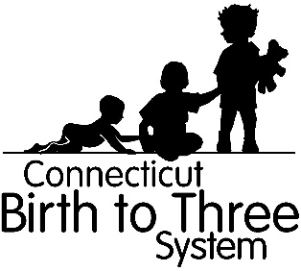

Dear Parent,

Thank you for talking with us about __________________________________. The program listed below will call you to schedule a visit for an evaluation.

Name of Program
Address
Phone Number
Contact Person

Please take a moment to read, "Welcome to The Connecticut Birth to Three System!". It contains information about Birth to Three and what to expect at your evaluation. We have also included a list of programs that serve your town and resources for your family.
If you have any questions, please feel free to call us at 1-800-505-7000.

Sincerely,

Birth to Three Intake Staff

Child Development Infoline
United Way of Connecticut
1344 Silas Deane Highway Rocky Hill, CT 06067

Addendum 2: Intake Referral Source Letter

1-800-505-7000  http://www.birth23.org | 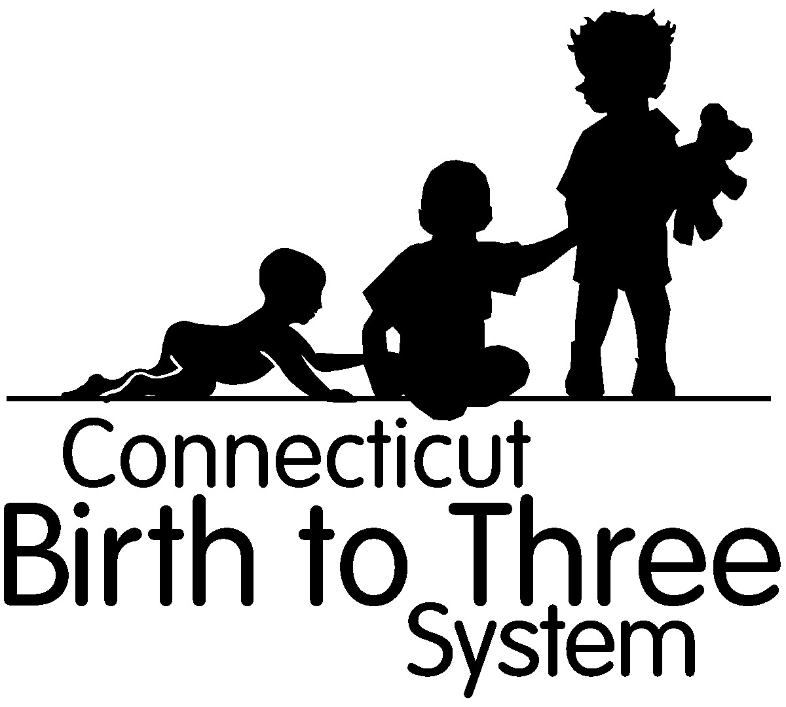

Dear ____________________:

Thank you for your recent referral to the Birth to Three System for
__________________________________ DOB _________. This referral was forwarded to the following program on _________________ for determination of eligibility and / or service needs:

Name of Program
Address
Phone Number
Contact Name

If you have questions or would like general information regarding the Birth to Three System, please feel free to call us at 1-800-505-7000.

Sincerely,

Birth to Three Intake Staff

Child Development Infoline
United Way of Connecticut
1344 Silas Deane Highway Rocky Hill, CT 06067

Addendum 3: Referral No Contact Letter

1-800-505-7000
http://www.birth23.org

Dear ____________________:

Your child, ______________________________, was referred to the Birth to Three System by _____________________________ for an evaluation of his/her growth and development.

We have been trying to reach you to explain in more detail the Birth to Three system, so you can decide if you would like your child to be evaluated. Please call us at 1-800-505-7000.

Until we hear from you, no further action will be taken on this referral. We will notify _________________that we have been unable to reach you to complete the referral process.

We hope to hear from you soon. Your call to Child Development Infoline is free and completely confidential.

Thank you.

Sincerely ,

Child Development InfoLine Staff

Child Development Infoline
United Way of Connecticut
1344 Silas Deane Highway Rocky Hill, CT 06067

Addendum 4: No contact Referral Letter
1-800-505-7000
http://www.birth23.org

Dear ___________________________,

Thank you for your recent referral to the Birth to Three System for:
Child:_____________ DOB:___________

____ We do not have sufficient information to process this referral. Please call us with complete information.

_____ The family never responded to our multiple attempts to contact them. Unless we hear from the family, the case will be closed.

_____ When the family was contacted, they indicated they were moving out of state

_____ The family was contacted and indicated they were not interested in our services at this time

_____ The family was contacted and indicated they were not interested in a Birth to Three evaluation at this time. However, they expressed interest in participating in the Ages and Stages Child Monitoring Program (ASQ) and a consent form to enroll in ASQ was mailed to the family.

_____ When we spoke to the family, it appeared that the child was doing well. Since Birth to Three is for children with significant delays, other information/services were offered that better match the child’s needs and abilities.

_____ The child’s third birthday is within 45 calendar days of this referral, therefore the parent was given information on how to refer their child for preschool special education from their local school district

_____ Other____________________________________________________________

Sincerely,

Child Development Infoline Staff

Child Development Infoline
United Way of Connecticut
1344 Silas Deane Highway Rocky Hill, CT 06067

Addendum 5: Ages and Stages letter

Date

Parent Name
Address

Re: Child's Name

Dear

Welcome to the Ages & Stages (ASQ) Child Monitoring Program, a free service provided by Help Me Grow through Child Development Infoline. Your child’s first 5 years are important and we want to help you provide the best start for your child’s future development. To assist with this, we offer the Ages & Stages Questionnaire, Third Edition (ASQ-3) to help you keep track of your child’s development by asking questions about some things your child can and cannot do.

Your child’s age (or developmental age, if born prematurely, up until 24 months) will determine when you will receive the first questionnaire.

ASQ questionnaires are available at 2, 4, 8, 12, 16, 20, 24, 27, 30, 33, 36, 42, 48, 54 and 60 months of age. You will receive questionnaires until your child’s fifth birthday.

Thank you for enrolling your child in the Ages & Stages Child Monitoring Program. If you have any questions, contact Help Me Grow / Child Development Infoline at 1-800-505-7000 or email us at CDI.ASQ.INFO@ctunitedway.org.

We look forward to your participation.

Sincerely,

Child Development Infoline Staff United Way of CT 1344 Silas Deane Highway Rocky Hill, CT 06067
https://cdi.211ct.org/

The Ages & Stages Child Monitoring Program is a service of Help Me Grow, a program of the Connecticut Office of Early Childhood

